Sam Tenney

Section 2

Homework 8

1. Caffeine-free Beverages
2. Response variable: the sum of 20 beverage taste judges, where each judge scores on a 1-10 scale (meaning higher Taste Scores reflect a better beverage).

Factors: Sweetener (Sugar, Corn Syrup, Aspartame, Ace-K) and Carbonation (Yes, No)

Treatments: There are eight treatment combinations of the factors and factor levels. They are as follows: Sugar-Yes, Sugar-No, Corn Syrup-Yes, Corn Syrup-No, Aspartame-Yes, Aspartame-No, Ace-K - Yes, Ace-K – No.

Experimental Unit: Taste judges who receive the drink combination and give it a Taste Score

1. This study is an experiment because the chemist randomly assigns experimental combinations to the judges and measures the response from the judges. A treatment is applied to an experimental unit which is not done in an observational study, but in an experiment.
2. # Read in the data from https://blades.byu.edu/stat230data/caffeine.txt  
   caffeine <- read.table(text = "run sweetener carbonation taste  
    1 CornSyrup No 189  
    2 Aspertame No 187  
    3 CornSyrup Yes 191  
    4 AceK Yes 173  
    5 Aspertame Yes 171  
    6 AceK No 180  
    7 Sugar No 187  
    8 CornSyrup Yes 184   
    9 Aspertame No 187  
   10 AceK No 185  
   11 Sugar No 190  
   12 AceK Yes 163  
   13 Sugar Yes 198  
   14 Sugar Yes 199  
   15 CornSyrup No 182  
   16 Aspertame Yes 178", header = TRUE, sep = '')
3. # Calculate the summary statistics for each treatment  
   aggregate(taste~sweetener+carbonation, data = caffeine, FUN = mean) aggregate(taste~sweetener+carbonation, data = caffeine, FUN = sd)

|  |  |  |  |
| --- | --- | --- | --- |
| Summary Statistics for Caffeinated Beverage Data | | | |
| Sweetener | Carbonation | Mean  Taste Score | Standard Deviation |
| Ace-K | No | 182.5 | 3.54 |
| Aspartame | No | 187.0 | 0.00 |
| Corn Syrup | No | 185.5 | 4.95 |
| Sugar | No | 188.5 | 2.12 |
| Ace-K | Yes | 168.0 | 7.07 |
| Aspartame | Yes | 174.5 | 4.95 |
| Corn Syrup | Yes | 187.5 | 4.95 |
| Sugar | Yes | 198.5 | 0.71 |

For the sweeteners Ace-K and Aspartame, the mean Taste Score seems to drop when carbonation was present, whereas for Corn Syrup and Sugar, the mean taste scores increased when carbonation was present. The spread for Corn Syrup taste scores remained the same with or without carbonation, but for Ace-K and Aspartame, the results were much more spread out from the mean when carbonation was present. Sugar’s Taste Score spread decreased when carbonation was present.

1. 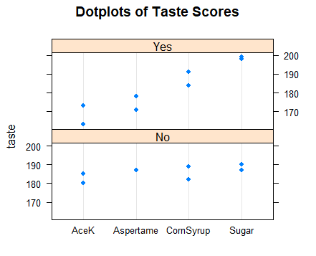

The spreads are similar whether carbonation is present or not. When carbonation is not in the drinks, the results seem to be more consistent across the different sweeteners, whereas when carbonation is in the drinks, Ace-K and Aspartame generally scored lower, while Corn Syrup and Sugar scored higher. It appears that Ace-K has the largest change in score when going from no carbonation to having carbonation present in the beverages. There are no unusual observations in our graph.

1. The ANOVA model for the caffeinated beverage data is yijk = µ + αi + βj + γij + ɛ­ijk. yijk is the taste score where each judge scores on a 1-10 scale (meaning higher Taste Scores reflect a better beverage) for the kth replicate of the ith sweetener level (Sugar, Corn Syrup, Aspartame, Ace-K) and the jth carbonation level (Yes or No). The variable µ is the grand mean of all the taste scores given by the judges on a scale from 1-10. The variable αi is the treatment effect for the ith sweetener level. The variable βj is the treatment effect for the jth carbonation level. The variable γij is the interaction effect for the ith sweetener level and the jth carbonation level. The error for the kth replicate with ith the sweetener level and the jth carbonation level is represented by ɛ­ijk.

# Create ANOVA table   
caffeineFacMod <- aov(taste~sweetener+carbonation+sweetener:carbonation, data = caffeine)  
anova(caffeineFacMod)

## Analysis of Variance Table  
##   
## Response: taste  
## Df Sum Sq Mean Sq F value Pr(>F)   
## sweetener 3 734.50 244.833 13.8913 0.001545 **  
## carbonation 1 56.25 56.250 3.1915 0.111840   
## sweetener:carbonation 3 414.25 138.083 7.8345 0.009132 **  
## Residuals 8 141.00 17.625   
## ---  
## Signif. codes: 0 '***' 0.001 '**' 0.01 '*' 0.05 '.' 0.1 ' ' 1

# Create table of 95% confidence intervals for all pair-wise comparisons of factor and interaction levels  
TukeyHSD(caffeineFacMod, which="sweetener:carbonation")

## Tukey multiple comparisons of means  
## 95% family-wise confidence level  
##   
## Fit: aov(formula = taste ~ sweetener + carbonation + sweetener:carbonation, data = caffeine)  
##   
## $`sweetener:carbonation`  
## diff lwr upr p adj  
## Aspertame:No-AceK:No 4.5 -12.1127398 21.1127398 0.9465629  
## CornSyrup:No-AceK:No 3.0 -13.6127398 19.6127398 0.9937505  
## Sugar:No-AceK:No 6.0 -10.6127398 22.6127398 0.8227965  
## AceK:Yes-AceK:No -14.5 -31.1127398 2.1127398 0.0950689  
## Aspertame:Yes-AceK:No -8.0 -24.6127398 8.6127398 0.5810259  
## CornSyrup:Yes-AceK:No 5.0 -11.6127398 21.6127398 0.9140444  
## Sugar:Yes-AceK:No 16.0 -0.6127398 32.6127398 0.0601896  
## CornSyrup:No-Aspertame:No -1.5 -18.1127398 15.1127398 0.9999214  
## Sugar:No-Aspertame:No 1.5 -15.1127398 18.1127398 0.9999214  
## AceK:Yes-Aspertame:No -19.0 -35.6127398 -2.3872602 0.0246064  
## Aspertame:Yes-Aspertame:No -12.5 -29.1127398 4.1127398 0.1743365  
## CornSyrup:Yes-Aspertame:No 0.5 -16.1127398 17.1127398 1.0000000  
## Sugar:Yes-Aspertame:No 11.5 -5.1127398 28.1127398 0.2342184  
## Sugar:No-CornSyrup:No 3.0 -13.6127398 19.6127398 0.9937505  
## AceK:Yes-CornSyrup:No -17.5 -34.1127398 -0.8872602 0.0383078  
## Aspertame:Yes-CornSyrup:No -11.0 -27.6127398 5.6127398 0.2704638  
## CornSyrup:Yes-CornSyrup:No 2.0 -14.6127398 18.6127398 0.9994824  
## Sugar:Yes-CornSyrup:No 13.0 -3.6127398 29.6127398 0.1500109  
## AceK:Yes-Sugar:No -20.5 -37.1127398 -3.8872602 0.0159894  
## Aspertame:Yes-Sugar:No -14.0 -30.6127398 2.6127398 0.1107351  
## CornSyrup:Yes-Sugar:No -1.0 -17.6127398 15.6127398 0.9999949  
## Sugar:Yes-Sugar:No 10.0 -6.6127398 26.6127398 0.3567804  
## Aspertame:Yes-AceK:Yes 6.5 -10.1127398 23.1127398 0.7667317  
## CornSyrup:Yes-AceK:Yes 19.5 2.8872602 36.1127398 0.0212838  
## Sugar:Yes-AceK:Yes 30.5 13.8872602 47.1127398 0.0012663  
## CornSyrup:Yes-Aspertame:Yes 13.0 -3.6127398 29.6127398 0.1500109  
## Sugar:Yes-Aspertame:Yes 24.0 7.3872602 40.6127398 0.0061540  
## Sugar:Yes-CornSyrup:Yes 11.0 -5.6127398 27.6127398 0.2704638

1. 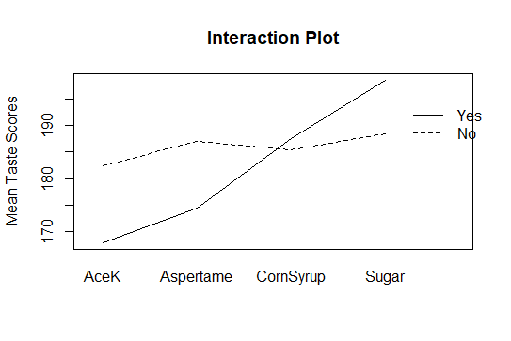

The most significant interaction difference is between Sugar:Yes-AceK:Yes with a p-value of about 0.001. The least significant interaction difference is between CornSyrup:Yes-Aspartame:No with a p-value of 1.00.

1. Check Assumptions

# Calculate Residuals  
caffeine$resids <- resid(caffeineFacMod)  
mean(caffeine$resids)

## [1] 1.249001e-16

# Index Plot: Check Independence  
plot(caffeine$resids, type="b")  
abline(h=0)

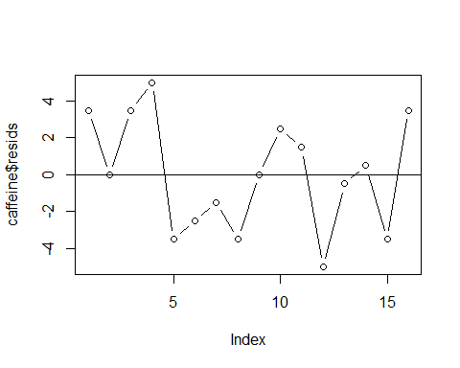

# Normal qq plot: check normality  
qqnorm(caffeine$resids)  
qqline(caffeine$resids)

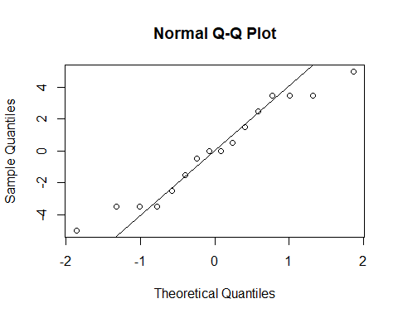

# Ratio of sds: check equal variance  
aggregate(taste~sweetener+carbonation, data = caffeine, FUN = sd)

## sweetener carbonation taste  
## 1 AceK No 3.5355339  
## 2 Aspertame No 0.0000000  
## 3 CornSyrup No 4.9497475  
## 4 Sugar No 2.1213203  
## 5 AceK Yes 7.0710678  
## 6 Aspertame Yes 4.9497475  
## 7 CornSyrup Yes 4.9497475  
## 8 Sugar Yes 0.7071068

The mean of our residuals is so small, we can say it’s zero, so we can assume the means of the different combinations are constant. The index plot above shows no real pattern, so we can assume our residuals are independent. The normal QQ plot is pretty straight, so we can assume that our residuals are normally distributed. Our standard deviation ratio, 7.07 / 2.12 (not counting dividing by zero) is greater than 2 so we can’t assume that our variances are constant. Not all the assumptions are met.

1. Choir Heights
2. Response variable: Height of singers in inches.

Factors: Sex (male, female) and singing part (low, high)

Conditions: There are four different conditions. Male-low, male-high, female-low, female-high.

Experimental Units: Each individual singer.

1. This is an observational study since no treatment is being applied by an external force. The researcher is simply observing data that has been collected about singers.

**data** singers;

infile datalines dlm=",";

input height sex $ part $;

datalines;

height,sex,part

64,f,high

62,f,high

66,f,high

65,f,high

60,f,high

....

low

72,m,low

66,m,low

72,m,low

70,m,low

69,m,low

;

**run**;

1. **proc** **glm** data=singers;

class sex part;

model height = sex|part;

means sex*part / tukey;

**run**;

|  |  |  |  |  |
| --- | --- | --- | --- | --- |
| Summary Statistics for Singers | | | | |
| Sex | Singing Part | Obs | Mean height (inches) | Std Dev  (inches) |
| Female | High | 36 | 64.25 | 1.87 |
| Female | Low | 35 | 64.89 | 2.79 |
| Male | High | 20 | 69.15 | 3.22 |
| Male | Low | 39 | 70.72 | 2.36 |

Naturally, the men are taller than women on average. It seems the singing part doesn’t make much of a difference in height for either sex as the only difference is bass singers were taller than tenors on average by about 1.5 inches. The height of tenors had a larger spread than any of the other singing parts while sopranos had the smallest spread on average.

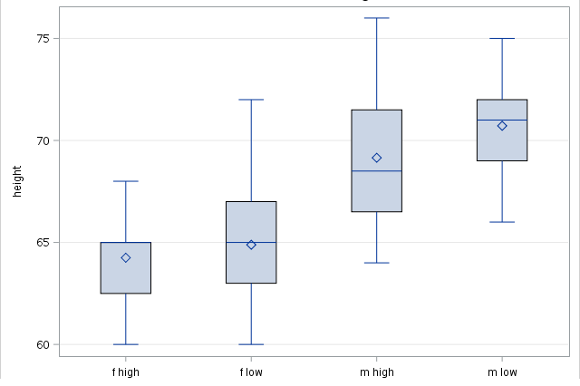

Females were shorter than the men on average. Tenors and altos had the largest spreads while sopranos and basses had the smallest spreads. It is difficult to tell what direction sopranos are skewed. Altos are nearly symmetric, tenors are slightly skewed right, and basses are slightly skewed left. There are no outliers according to the boxplots.

1. The ANOVA model for the singers data is yijk = µ + αi + βj + γij + ɛ­ijk. yijk is the height in inches for the kth  (where k = 1, …, nij) replicate of the ith sex level (male, female) and the jth singing part level (low, high). The variable µ is the grand mean of all the singers’ heights in inches. The variable αi is the treatment effect for the ith sex level. The variable βj is the treatment effect for the jth singing part level. The variable γij is the interaction effect for the ith sex level and the jth singing part level. The error for the kth replicate with ith the sex level and the jth singing part level is represented by ɛ­ijk.

**proc** **glm** data=singers;

class sex part;

model height = sex|part;

means sex*part / tukey;

**run**;

|  |  |  |  |  |  |
| --- | --- | --- | --- | --- | --- |
| ANOVA Table using Type I SS | | | | | |
| Source | DF | Type I SS | Mean Square | F Value | p-Value |
| Sex | 1 | 1018.86 | 1018.86 | 161.13 | <.0001 |
| Part | 1 | 33.09 | 33.09 | 5.23 | 0.02 |
| Sex * Part | 1 | 6.58 | 6.58 | 1.04 | 0.31 |

The main effects, or rather, when sex and singing part are accounted for separately, the heights of the singers are significantly different when they are the next term in the model, since both of their p-values are lower than 0.05. The difference in heights is not significant, however, when looking at the interaction effect between sex and singing part when they are the next term in the model.

|  |  |  |  |  |  |
| --- | --- | --- | --- | --- | --- |
| ANOVA Table using Type III SS | | | | | |
| Source | DF | Type III SS | Mean Square | F Value | p-Value |
| Sex | 1 | 872.65 | 872.65 | 138.00 | <.0001 |
| Part | 1 | 36.79 | 36.79 | 5.82 | 0.02 |
| Sex * Part | 1 | 6.58 | 6.58 | 1.04 | 0.31 |

The main effects, or rather, when sex and singing part are accounted for separately, the heights of the singers are significantly different when they are the last term in the model, since both of their p-values are lower than 0.05. The difference in heights is not significant, however, when looking at the interaction effect between sex and singing part when they are the last term in the model.

1. The SS for sex is smaller in the Type III model because the Type I model takes into account the order the data is read in. The previous data has an effect on the variance, and since we read in the data by sex with females first, this had an effect on our variance since their heights are different than males. The Type III model makes its calculations as if each data entry is the last one, so previous data entries don’t have as large of an effect on the variance.